**PLAYING FIELDS/VILLAGE HALL WORKS DAY**

**Saturday 15 February 10.00am**

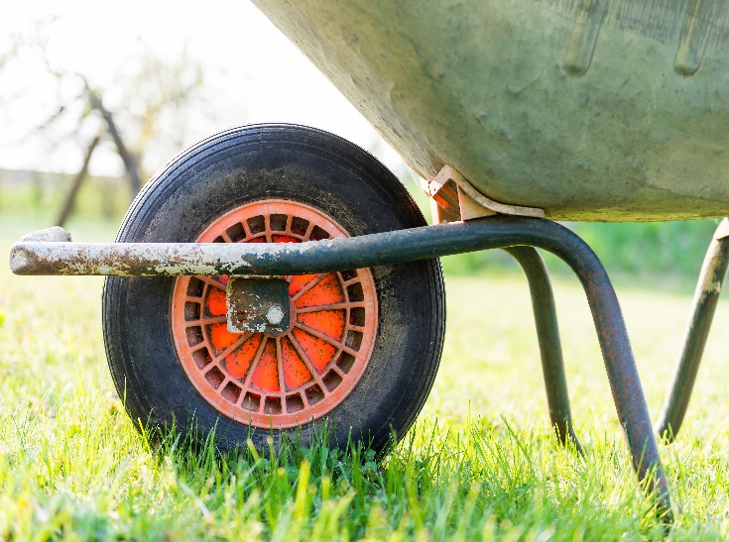

**HELP NEEDED FOR A COUPLE OF HOURS**

**WHEELBARROWS, SHOVELS AND ELBOW GREASE NEEDED**

WE ARE HAVING A WORKING MORNING TO READY THE PETANQUE FOR OPENING, RESURFACING ACCESS TO THE HALL, SKIRTING BOARD AND INDOOR WINDOW CLEANING AND GENERAL MAINTENANCE.

Tea and Coffee on tap. Please try and join us to get ready for Spring.

Thank you in anticipation. Stourpaine Playing Fields and Village Hall Association